Contents
1.INTRODUCTION 1
1.1 Purpose 1
1. PROBLEM DEFINITION 1
2. EXISTING SYSTEMS 2
3.1 Yahoo Messenger 2
3.2 MSN Messenger 2
3.3 Skype 2
3. SYSTEM ENVOIRMENT 2
4. SYSTEMS REQUIREMENTS 3
5.1 Software Interface 3
5.2 Hardware Interface 3
6. SCOPE 4
7. SYSTEM ARCHITECTURE 5
8. SYSTEM DESIGN 5
9. SYSTEM SPECIFICATION 6
10. ABBREVIATIONS 8
11.TECHNOLOGIES 12
12. DIAGRAMS 13
13. FUTURE SCOPE 19
14.CONCLUSION 19
15. REFRENCES 19
16. SCREENSHOTS 20

1.INTRODUCTION

1.1 Purpose

Our computer technology is changing exponentially. This evolution has been very vast and beneficial. Starting from analog computers to DOS, the introduction of Windows, MAC, LINUX and after that it is an entirely different story. The platforms and software’s is becoming more and more user friendly. They provide more features and entertainment possibilities which were not possible earlier. The users now want demand a technology that is really easy to use and provides as many features the user can imagine. The software has become user oriented along with encompassing the necessary functions to provide users to perform tec
hnical tasks.

“SLATE BOARD” is a user oriented software that is concerned of the users entertainment and provide other functions such as, file transfer, Mp3 player and a white board. It is an integrated technology that can provide multitasking of different features. Thus it is basically developed keeping in mind the needs of the user and providing key functions as well as full proof entertainment. It is a system messenger type communicational and an entertainment device and provides a high level of user friendliness.

This application has been designed for multiple applications to run on a single application to make it more convenient for the user to just buy legal software for one application rather than different software with different legal agreement. Just to reduce the cost of the system this application would be very useful to common people. Needing an inbuilt application having multiple embedded application.

This application would provide the user with:

- White Board.
- File transfer.
- MP3 Player.

PROBLEM DEFINITION

The computer technology is evolving day by day. The process of evolution has concentrated on simplicity and versatility. Today the users want more and more features in a single application. They have grown restless and support multiple functionalities with minimum effort. The user wants to have all for nothing. Due to the evolution in the users personalities it is important to provide multiple features in a single application so that the user does not lose interest. This major problem needs to tackled otherwise there is a quick change in a users mentality. Also all the application that provide such features are quite costly and difficult to implement for an individual.

- White Board

The user can write text for various illustrations .He can create different shapes of varying sizes and can color them according to his wish using the RGB standard as used in the code.

- File transfer protocol

This application is to meet the requirements of transferring the files over the LAN. This software provides an easy way to create, maintain user account and transferring of files between Server and Client. For storing the information (username and encrypted password) Database is used so that it is easy to retrieve and maintain this information. Every user has a particular directory on the server hard disk where user can store his/her own files in that directory and can retrieve the files from this directory only.
Administrator is able to create, delete the particular user according to the requirement, administrator is able to see all users and their account ID as well as Password.

- MP3 player

This application uses the java embedded packages to run a mp3 format file using some mp3 player.

SLATE BOARD can perform various functionalities.

- Restart (Restart the Applet).
- Reload (Re run the program).
- Stop (Applet working would stop).
- Save (Save the file so that it could be used later).
- Start (Start the applet).
- Clone (Make a duplicate copy of applet using the clone).
- Character encoding (system consists of a code that pairs each character from a given repertoire with something.).
- Print (print the page that we have drawn).
- Quit (Exit the applet).
- Drawing shapes for eg. Rectangle, circle, line, write text.
- Color the shape.
- Fill shapes with possible color that could be made by a RGB standard.
- At the task bar find out the “color mode”, “tool mode” ,”cursor position using the X-Y coordinate system”.
- Clear the page.
- Eraser.
- Player (opens a mp3 player).
- Play(play a song)
- Pause(pause pause a song)
- Mute(mutes a song)
- Transfer(transfer a file using ftp protocol)
- Buzz(creates a buzz sound at the second client window.

EXISTING SYSTEMS

3.1 Yahoo Messenger

Yahoo! Messenger is an advertisement-supported instant messaging client and associated protocol provided by Yahoo!. Yahoo! Messenger is provided free of charge and can be downloaded and used with a generic "Yahoo! ID" which also allows access to other Yahoo! services, such as Yahoo! Mail, where users can be automatically notified when they receive new email. Yahoo! also offers PC-PC, PC-Phone and Phone-to-PC service, file transfers, webcam hosting, text messaging service, and chat rooms in various categories.

3.2 MSN Messenger

Windows Live Messenger uses the Microsoft Notification Protocol (MSNP) over TCP (and optionally over HTTP to deal with proxies) to connect to the .NET Messenger Service.

The .NET Messenger Service servers currently only accept protocol versions from 8 and higher, so the syntax of new commands sent from versions 8 and higher is only known by using packet sniffers like Wireshark. This has been an easy task because - in comparison to many other modern instant messaging protocols, such as XMPP - the Microsoft Notification Protocol does not provide any encryption and everything can be captured easily using packet sniffers.

3.3 Skype

Skype is a software application that allows users to make voice calls over the Internet. Calls to other users within the Skype service are free, while calls to both traditional landline telephones and mobile phones can be made for a fee using a debit-based user account system. Skype has also become popular for its additional features which include instant messaging, file transfer, and video conferencing

SYSTEM ENVOIRMENT

The front end is designed and executed with the JDK1.6.0 handling the core java part with User interface Swing component. Java is robust , object oriented , multi-threaded , distributed , secure and platform independent language. It has wide variety of package to implement our requirement and number of classes and methods can be utilized for programming purpose. These features make the programmer’s to implement to require concept and algorithm very easier way in Java.

The features of Java as follows:

- Core java contains the concepts like Exception handling, Multithreading; Streams can be well utilized in the project environment.
- The Exception handling can be done with predefined exception and has provision for writing custom exception for our application.
- Garbage collection is done automatically, so that it is very secure in memory management.
- The user interface can be done with the Abstract Window tool KitAnd also Swing class. This has variety of classes for components and containers. We can make instance of these classes and this instances denotes particular object that can be utilized in our program.
- Event handling can be performed with Delegate Event model. The objects are assigned to the Listener that observe for event, when the event takes place the corresponding methods to handle that event will be called by Listener which is in the form of interfaces and executed.
- This application makes use of Action Listener interface and the event click event gets handled by this. The separate method actionPerformed() method contains details about the response of event.
- Java also contains concepts like Remote method invocation; Networking can be useful in distributed environment.

SYSTEMS REQUIREMENTS

5.1 Software Interface

- Client on the internet: JVM, JDK (Latest), Operating system (ANY)
- Development end: Net beans 6.8, Operating system (any), Core JAVA.

5.2 Hardware Interface

- USER SIDE or CLIENT- INTERNET EXPLORER, MOZILLA FIREFOX, JVM.
- Keyboard, Mouse, Hard disk

Client
 | Version | RAM* | Memory*
- JDK | jdk1.6.0_18 | 256 MB | 1 GB
- JVM | JVM | 256 MB | 1 GB
Server
 | Version | RAM* | Memory*
- Disk | Any | 256 MB | 8 GB

*Minimum amount required.

5.3 Communication Interface

- Client on its side will be using JVM.
- Server will be just allocating whether client has authenticate to use the application or not. By sending the response Acknowledgement to the user.

6. SCOPE

- Draw shapes and lines according the user length shape and size.
- Fill color in them.
- Clear the screen if u totally wants to clear the screen.
- Write text
- Erase the unnecessary text using the eraser.
- Save file of applet.
- Restart or reload the applet.
- Using the proxy address make a connection, such that have one client and one server. And using this white board will show whatever data you are typing on the client will be received by server or vice- versa.
- Could be used as a substitute of the Paint brush after adding more functionality.
- Transfer various created files through the slate to other users as well as transfer various other files on the system by browsing them over the computer.
- Buzz the client on the system.
- Know what other clients are online on the server and create links to chat or transfer files.
- Listen to songs stored in the memory of the system in the background by browsing through them stored in various drives of the system.
- Create playlists of the songs you want to listen.
- Listen to various songs in the background while working on the slate.
- Since it is made on java platform so it is platform independent can be used on any operating system.
- Becomes more users friendly.
- Easily accessible.
- Easy to use.
- Much secure and reliable.

7. SYSTEM ARCHITECTURE

- Users: Client and technology provider
- Client sends the request according to the server. Server verifies the client and let it use the technology.

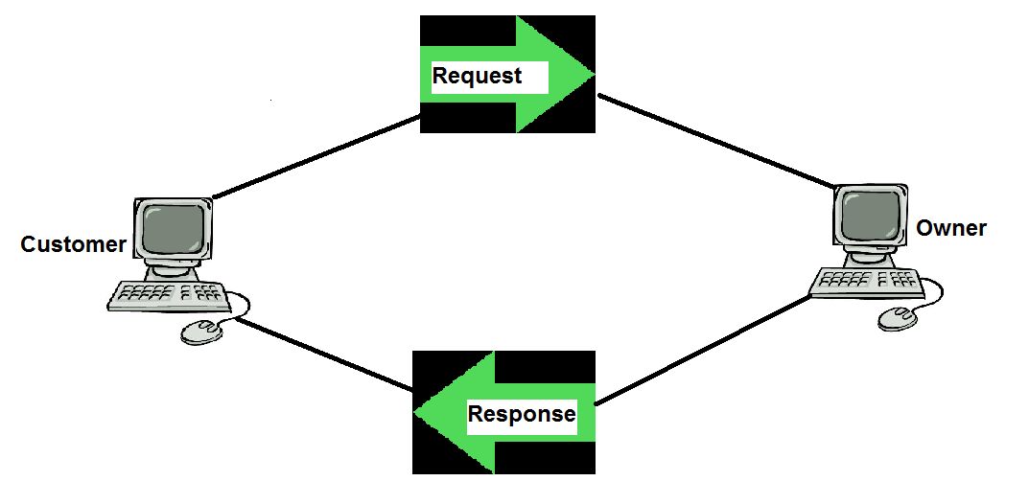

Fig 7.1 System architecture

8. SYSTEM DESIGN

Modules

The passage of time has introduced a major change in the mentality of a software users. They want it to be as simple as possible, easy to use and be fun that is it should provide entertainment along with other tasks so multimedia slate is designed keeping all these perspectives in mind . The various features of the system are as follows:

8.1 File Transfer

A user can transfer various types of files to any other user using this feature. He can share various images, audio file, data files etc. This allows the user to share his data and makes desk work easier MP3

This feature is based to provide the user a source of entertainment along with his normal work. He can listen to songs loaded from the main hard drive and browse through his selections providing a mood for relaxation along the process

8.2 Whiteboard

“Imagination is better than knowledge” the famous quote of Albert Einstein is what we have tried to encompass in this device. A user can draw any thing he desire and scribble away his name using various colors using the pen function of this device.

8.2 Music Player

A user can use this option to play files, create playlists, stop a playing track or pause it thus having a full musical entertainment on the tips of his fingers .

This project provides various methodologies to perform various functions of applet.

Since it is a standalone application so it could be only run through two methods.

1.Person should have JDK latest version installed in his system.
2.Person can embed this applet application on the website and execute this application via and web browser or any netscape.

9. SYSTEM SPECIFICATION

This project aims at creating an application called “ SLATE BOARD”. It has various application and the combined functionalities are together said multimedia slate.

- White Board

The user can write text for various illustrations .He can create different shapes of varying sizes and can color them according to his wish using the RGB standard as used in the code.

- File transfer protocol

This application is to meet the requirements of transferring the files over the LAN. This software provides an easy way to create, maintain user account and transferring of files between Server and Client. For storing the information (username and encrypted password) Database is used so that it is easy to retrieve and maintain this information. Every user has a particular directory on the server hard disk where user can store his/her own files in that directory and can retrieve the files from this directory only.
Administrator is able to create, delete the particular user according to the requirement, administrator is able to see all users and their account ID as well as Password.

- MP3 player

This application uses the java embedded packages to run a mp3 format file using some mp3 player.

SLATE BOARD can perform various functionalities.

- Restart (Restart the Applet).
- Reload (Re run the program).
- Stop (Applet working would stop).
- Save (Save the file so that it could be used later).
- Start (Start the applet).
- Clone (Make a duplicate copy of applet using the clone).
- Character encoding (system consists of a code that pairs each character from a given repertoire with something.).
- Print (print the page that we have drawn).
- Quit (Exit the applet).
- Drawing shapes for eg. Rectangle, circle, line, write text.
- Color the shape.
- Fill shapes with possible color that could be made by a RGB standard.
- At the task bar find out the “color mode”, “tool mode” ,”cursor position using the X-Y coordinate system”.
- Clear the page.
- Eraser.
- Player (opens a mp3 player).
- Play(play a song)
- Pause(pause pause a song)
- Mute(mutes a song)
- Transfer(transfer a file using ftp protocol)
- Buzz(creates a buzz sound at the second client window)

The Applet has been created using JAVA applications and importing inbuilt java applet packages.

This project includes a number of additional functionalities that we would discuss in the future scope.

10. ABBREVIATIONS

- JDK

The Java Development Kit (JDK) is a Sun Microsystems product aimed at Java developers. Since the introduction of Java, it has been by far the most widely used Java SDK

The JDK has as its primary components a collection of programming tools, including:

java – the loader for Java applications. This tool is an interpreter and can interpret the class files generated by the javac compiler. Now a single launcher is used for both development and deployment. The old deployment launcher, jre, no longer comes with Sun JDK.

- javac – the compiler, which converts source code into Java bytecode

- jar – the archiver, which packages related class libraries into a single JAR file. This tool also helps manage JAR files.

- javadoc – the documentation generator, which automatically generates documentation from source code comments

- jdb – the debugger

- jps – the process status tool, which displays process information for current Java processes

- javap – the class file disassembler

- appletviewer – this tool can be used to run and debug Java applets without a web browser.

- javah – the C header and stub generator, used to write native methods

- javaws – the Java Web Start launcher for JNLP applications

- extcheck – a utility which can detect JAR-file conflicts.

- apt – the annotation-processing tool

- jhat – (experimental) Java heap analysis tool

- jstack – (experimental) utility which prints Java stack traces of Java threads

- jstat – (experimental) Java Virtual Machine statistics monitoring tool

- jstatd – (experimental) jstat daemon

- jinfo – (experimental) This utility gets configuration information from a running Java
- process or crash dump.

- jmap – (experimental) This utility outputs the memory map for Java and can print shared object memory maps or heap memory details of a given process or core dump.

- idlj – the IDL-to-Java compiler. This utility generates Java bindings from a given IDL file.

- policytool – the policy creation and management tool, which can determine policy for a Java runtime, specifying which permissions are available for code from various sources

- VisualVM – visual tool integrating several command line JDK tools and lightweight performance and memory profiling capabilities

- wsimport – generates portable JAX-WS artifacts for invoking a web service.

- jrunscript – Java command-line script shell.

The JDK also comes with a complete Java Runtime Environment, usually called a private runtime. It consists of a Java Virtual Machine and all of the class libraries present in the production environment, as well as additional libraries only useful to developers, such as the internationalization libraries and the IDL libraries.

- JRE.

Java run time environment.

- Package:

A Java package is a mechanism for organizing Java classes into namespaces similar to the modules of Modula. Java packages can be stored in compressed files called JAR files, allowing classes to download faster as a group rather than one at a time. Programmers also typically use packages to organize classes belonging to the same category or providing similar functionality.

- A package provides a unique namespace for the types it contains.
- Classes in the same package can access each other's package-access members.

- RGB:

The RGB color model is an additive color model in which red, green, and blue light are added together in various ways to reproduce a broad array of colors. The name of the model comes from the initials of the three additive primary colors, red, green, and blue.

- Clone:

In computing, a clone is a hardware or software system that is designed to mimic another system. Compatibility with the original system is usually the explicit purpose of cloning hardware or low-level software such as operating systems.

Application software can be cloned simply by providing similar functionality (all word processors have the same basic purpose), but may also be designed to support specific file formats.

Application software can be cloned simply by providing similar functionality (all word processors have the same basic purpose), but may also be designed to support specific file formats.

- Applet

Applet as standalone application. Some applets are able to function as any other normal software application (provided they are hosted by an OS, but are small in size and perform only a small set of tasks. Examples of applications often classified as applets are all of the accessories bundled in Microsoft Windows (such as Windows Notepad or Microsoft Paint). Applets are not full-featured application programs.

- Character encoding

A character encoding system consists of a code that pairs each character from a given repertoire with something else, such as a sequence of natural numbers, octets or electrical pulses, in order to facilitate the transmission of data (generally numbers and/or text) through telecommunication networks or storage of text in computers.

- JVM

A Java Virtual Machine (JVM) enables a set of computer software programs and data structures to use a virtual machine model for the execution of other computer programs and scripts. The model used by a JVM accepts a form of computer intermediate language commonly referred to as Java bytecode.
Java Virtual Machines operate on Java bytecode, which is normally (but not necessarily) generated from Java source code; a JVM can also be used to implement programming languages other than Java.

- RAM

Random-access memory (usually known by its acronym, RAM) is a form of computer data storage. Today, it takes the form of integrated circuits that allow stored data to be accessed in any order (i.e., at random). "Random" refers to the idea that any piece of data can be returned in a constant time, regardless of its physical location and whether or not it is related to the previous piece of data.

By contrast, storage devices such as magnetic discs and optical discs rely on the physical movement of the recording medium or a reading head. In these devices, the movement takes longer than data transfer, and the retrieval time varies based on the physical location of the next item.

- FTP

File Transfer Protocol is a standard network protocol used to copy a file from one host to another over a TCP/IP-based network, such as the Internet. FTP is built on client-server architecture and utilizes separate control and data connections between the client and server.FTP is used with user-based password authentication or with anonymous user access.

- JMF

Java Media Framework the Java Media Framework Application Programming Interface (JMF API) enables audio, video and other time-based media to be added to applications and applets built on Java technology. This optional package, which can capture, playback, stream, and transcode multiple media formats

- JMS

The Java Message Service (JMS) API is a messaging standard that allows application components based on the Java 2 Platform, Enterprise Edition (J2EE) to create, send, receive, and read messages. It enables distributed communication that is loosely coupled, reliable, and asynchronous.

- P2P

Peer-to-peer (P2P) computing or networking is a distributed application architecture that partitions tasks or workloads between peers. Peers are equally privileged, equipotent participants in the application. They are said to form a peer-to-peer network of nodes.

11.TECHNOLOGIES

- Netbeans 6.8
- JDK
- JRE
- Any operating system.
- HTML
- JVM(Java Virtual Machine)
- JMS
- JMF
- FTP
- TCP

- Java Socket Programming

In order to develop client server architecture Java socket programming has been used. The complete project is divided into two parts:

- Server Program

It runs on the server machine. It handles all request from the clients and maintains corresponding Data base. It should be run first so that client can send request to it. It provides user friendly GUI that help an administrator to work.

- Client Program

It runs on the each client’s machine. It sends request and take response from the server. It provides user friendly GUI.

12. Diagrams

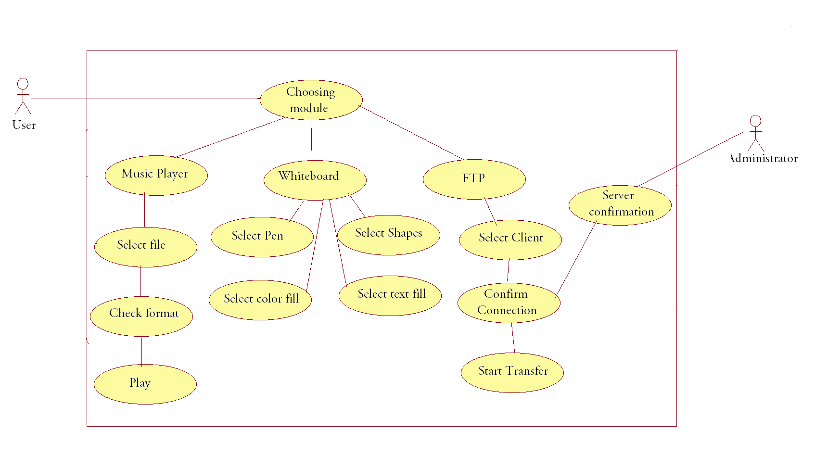
12.1 Use case

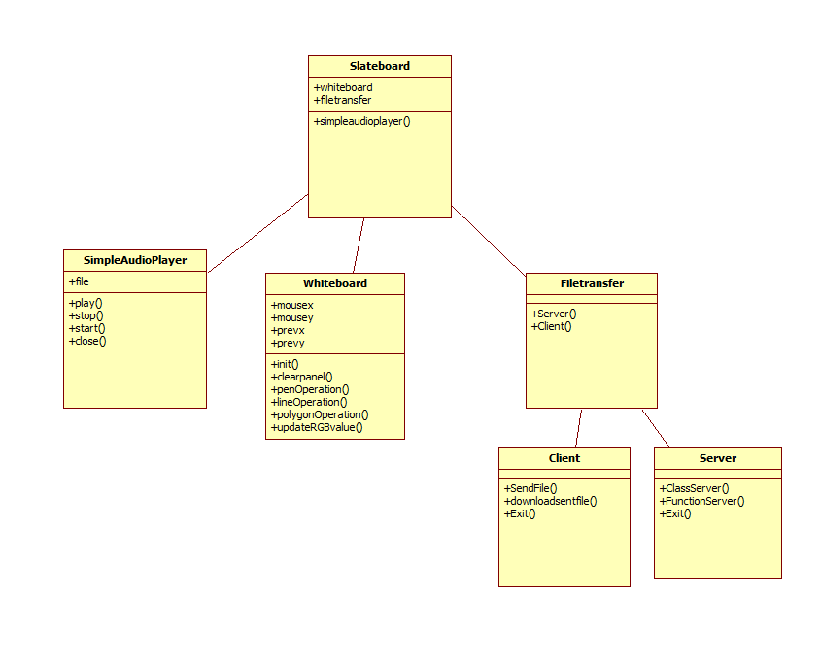

12.2 Class Diagram

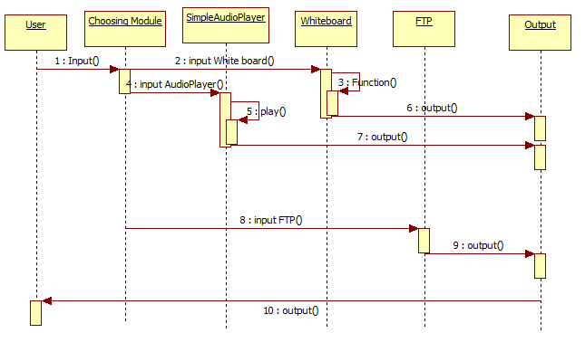
12.3 Sequence Diagram

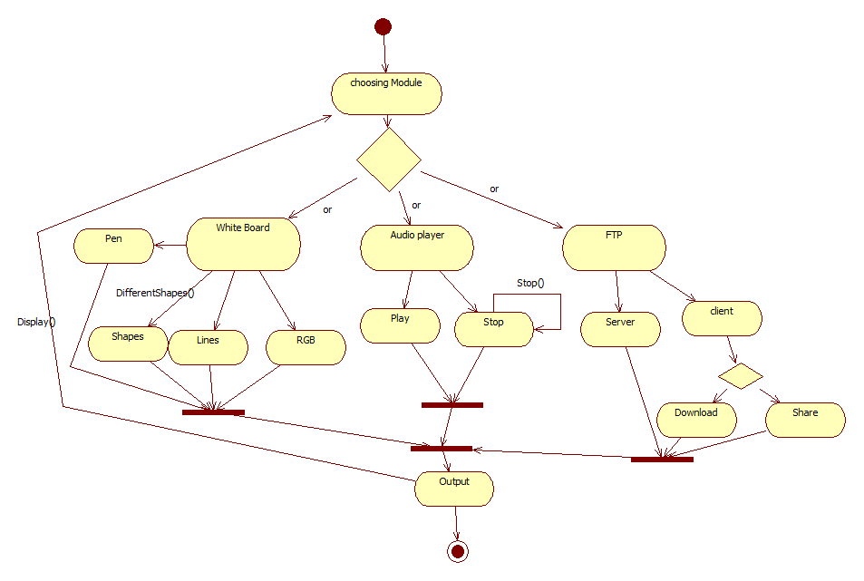

12.4 Sequence Diagram

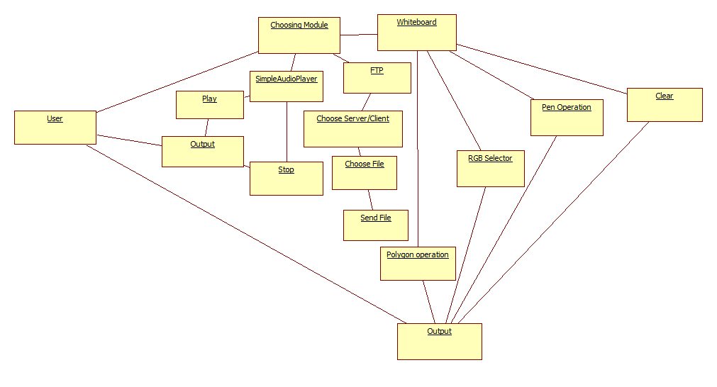
12.5 Collaboration Diagram

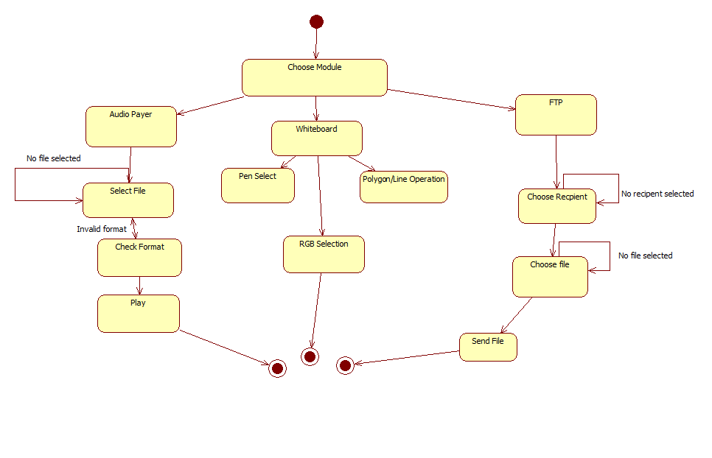
12.6 State Chart Diagram

13. FUTURE SCOPE

- This system is a java oriented so as per now it won’t have any difficulty in running in other Operating system.

- Security of the system could be increased by authentication from administrator.

- Could be embedded in the html page so it would be accessible to everyone anyone who uses the internet.

- This Application can have many more methodologies according to the requirement like different shapes, figures, buttons but it would need more space and time to implement and that would be on the large scale.

- Restricting the size of particular user directory on the Server.

- Facility of friend means a client may give access to some particular files present in his directory on the server to other client

- Adding the facility of Network printer.

- It can be enhanced in the field of voice chatting. Using VoIP protocol.

- It can be enhanced in the field of Video Conferencing.

14. CONCLUSION

User satisfaction is the main priority in evolving technological times. The study of user priorities and user mentality is a must now days, and more and more software are being developed through the perspective of a common man. “SLATE BOARD” is a software developed keeping all these perspectives in mind implementing its simplicity and versatility.
Thus the user enjoys simple and multiple functionalities in a single application.

15. REFRENCES

- www.Wikipedia.org
- www.Acclebrate.com
- Headfirst.
- The complete reference(java)
- Javabeginner.com

16. Screen shots

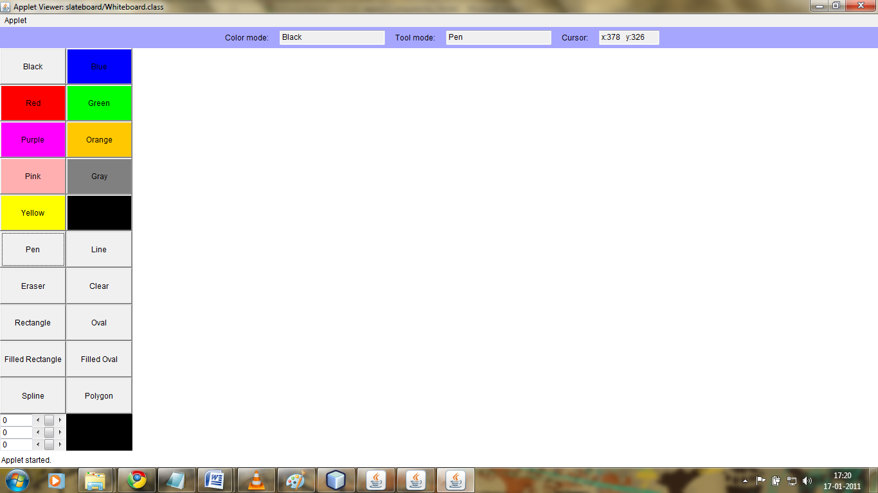

16.1 Simple Slate Board

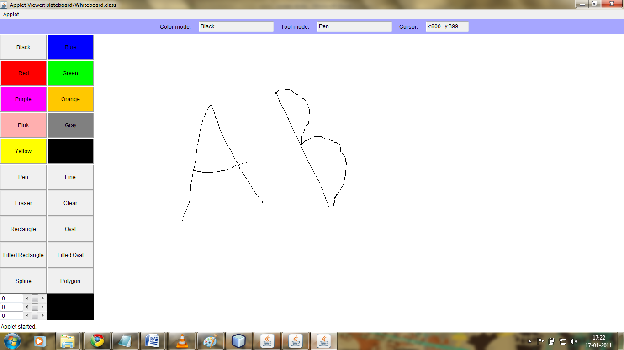

16.2 Slate Board Pen

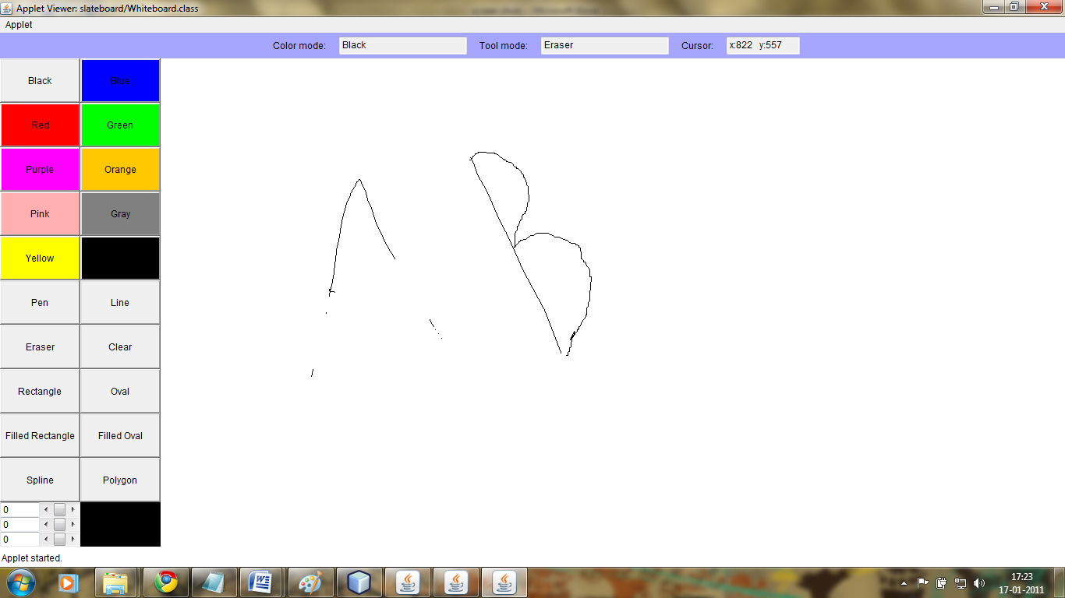

16.3 Slate Board Eraser

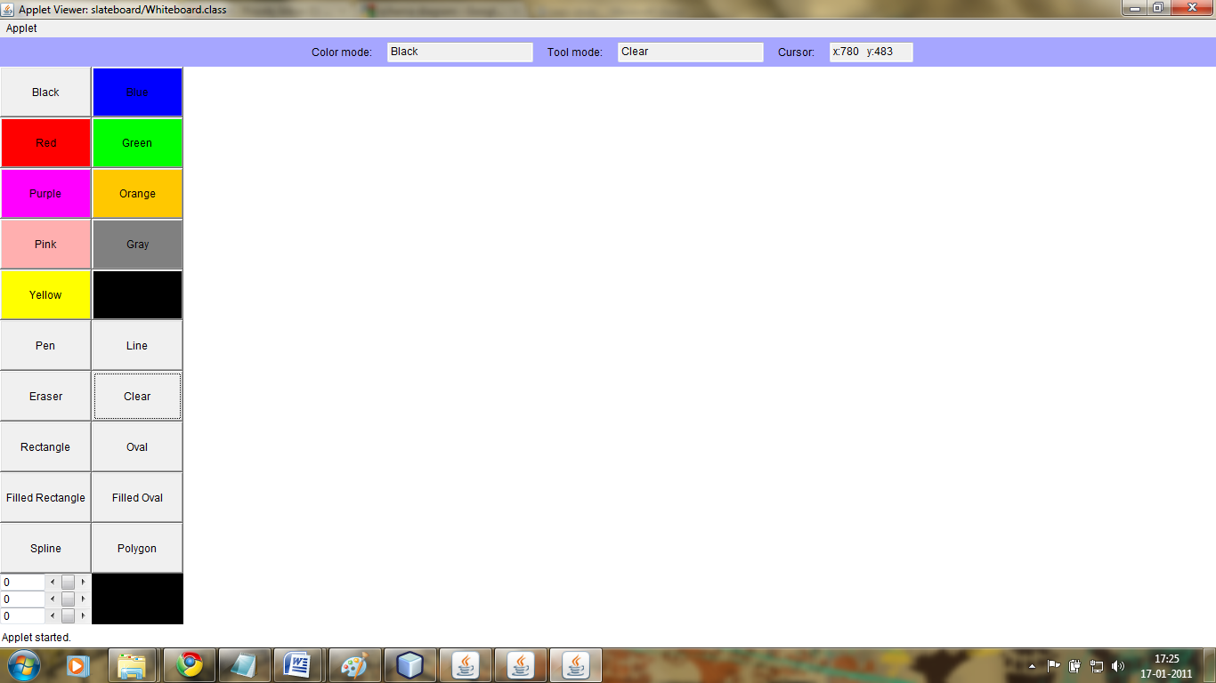

16.4 Slate Board Eraser

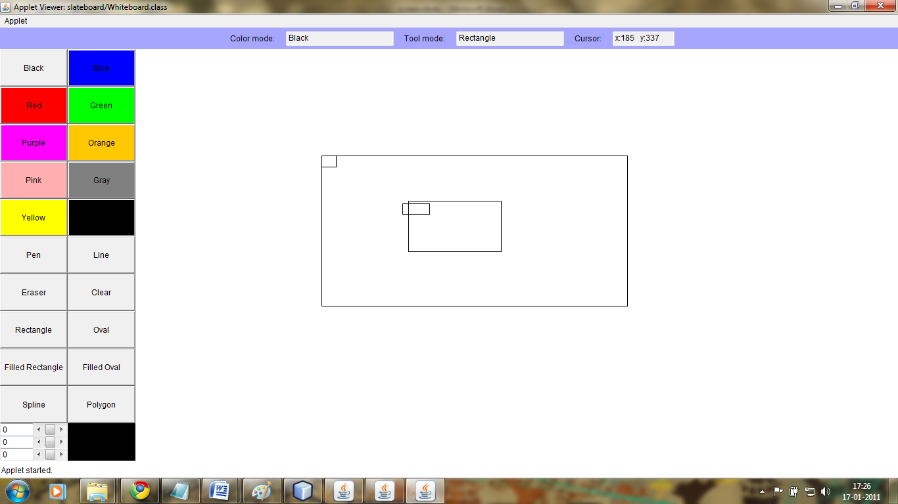

16.5 Slate Board Rectangle

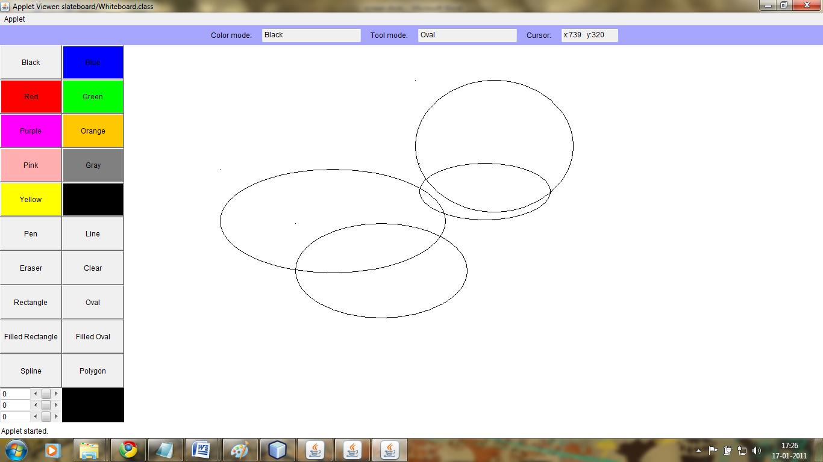

16.6 Board Oval

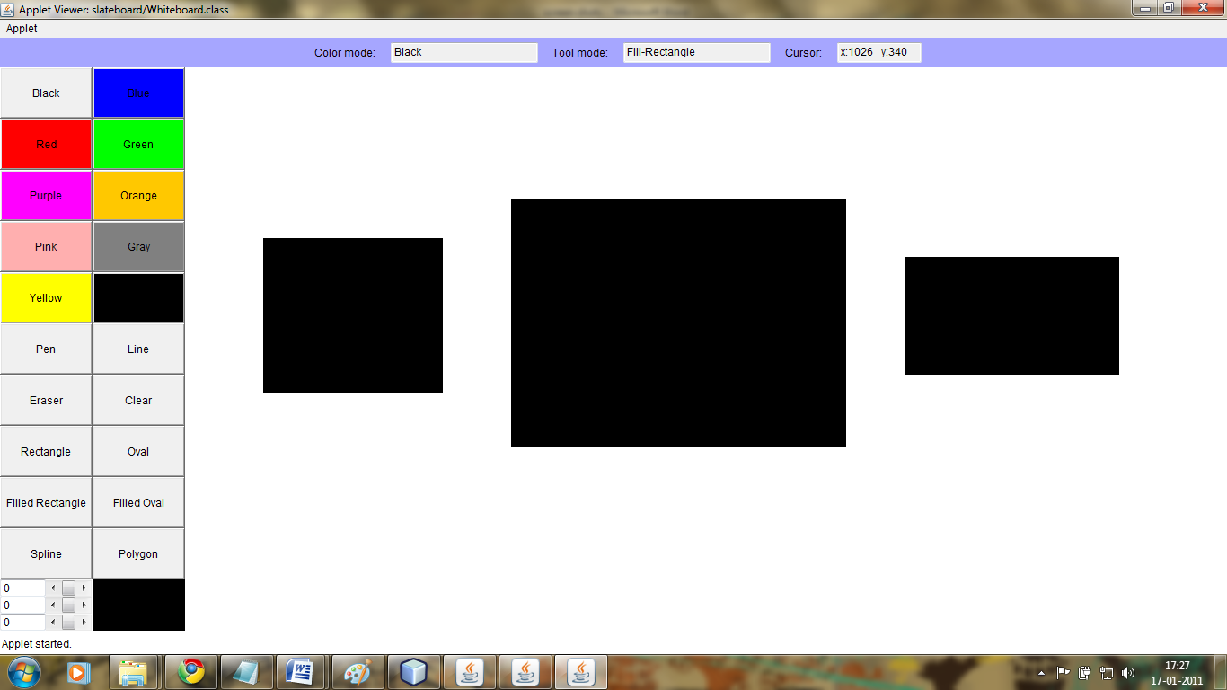

16.7 Slate Board Filled Rectangle

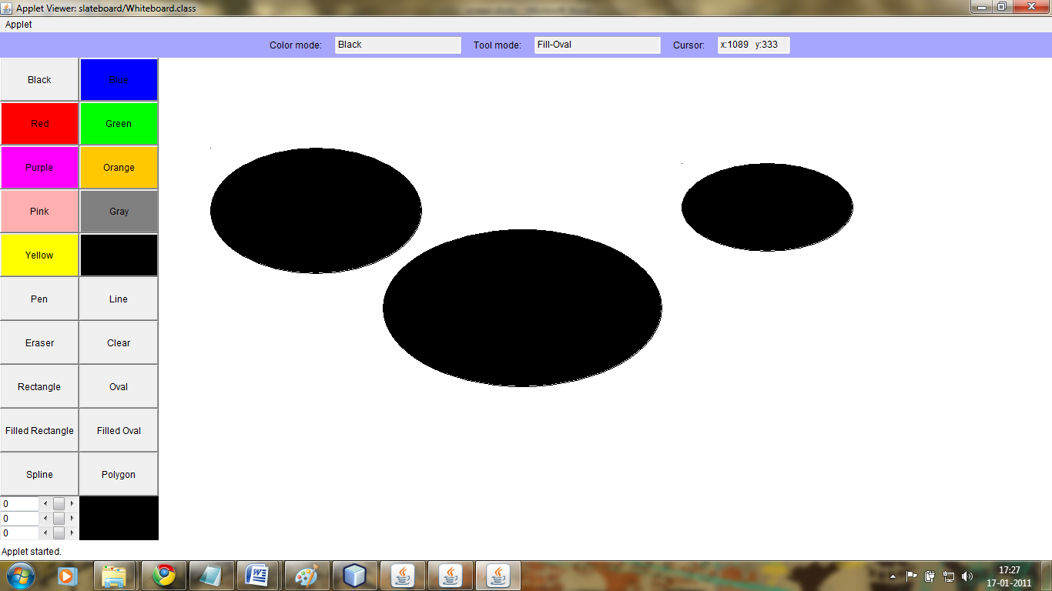

16.8 Slate Board Filled Oval

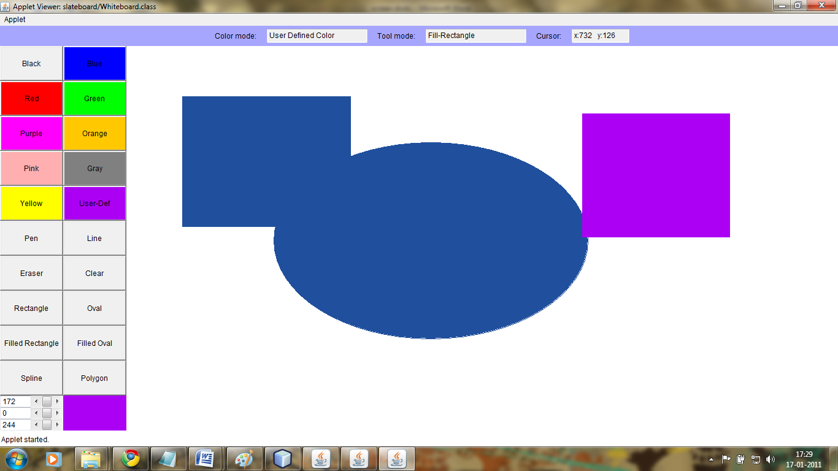

16.9 Slate Board User defined Color

